Concert Request Form

Name of Group:
Date of Concert: Concert Time: Arrival Time:

Contact Name: Phone:
Address:
Email: Web Address:

Rehearsal time requested:
Please list requested dates and time frames. St. George’s will do our best to accommodate these given the Nave’s schedule.
First Choice:
Second Choice:

Group/Concert Details:
Number in performing group: Estimated audience size:
Instrumentation:
Ticket prices: Advanced sales:

Concert Title:
Concert description:

St. George’s Instrument Use:
A $150 fee applies to the use of each these instruments. They will be tuned for your concert.
Steinway Grand Piano Location:
Harpsichord? Location:

Setup Needs:
Space configuration: please mark your proposed set up on the back page.
How many music stands? How many chairs?
Sound System: Number of Microphones:
St. George’s Sound system is available for public address, with up to three hand held wireless mics.
Any other setup needs?

Provided:
Publicity: St. George’s will post your concert on its concert calendar on its music website.
All other publicity is the responsibility of the ensemble/organization.
Rental Fee:
Instrument Fee:
Total:

Rental fees: Rental of the Nave for concerts is based on a sliding scale.
A $300 refundable damage deposit is required to reserve the space.

Please mark your desired set up on this diagram of the Nave, and/or describe below.

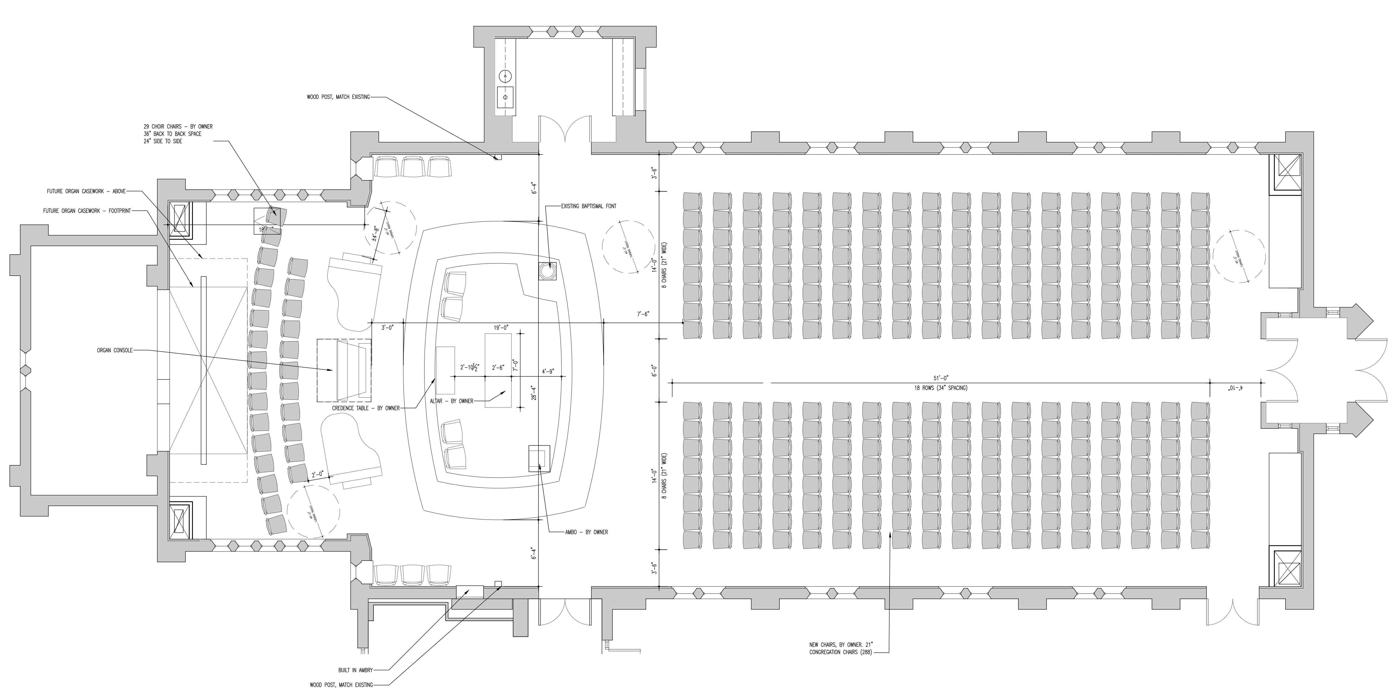

OFFICE USE:
Approved:
Rental Fee: Instrument Fee:
Deposit:
Concert Series: YES NO Publicized:
Tuning Scheduled:

